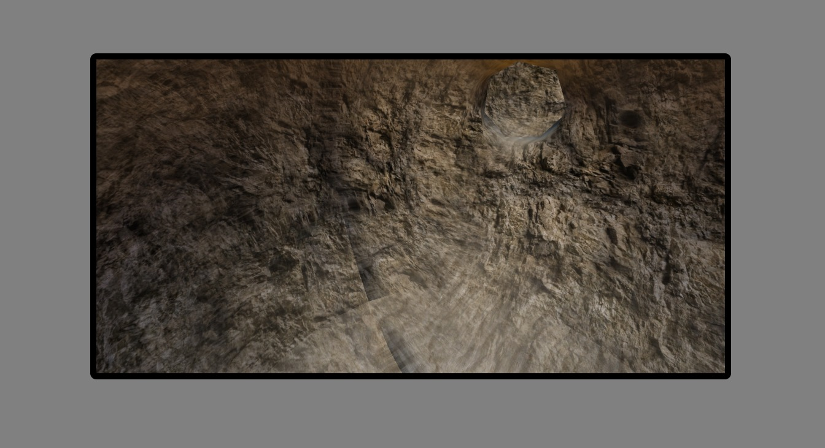

I selected caves because that stood out to me the most out of all the other options. Also, I love studying nature and landscape, so it made sense to go after my interests. The display picture of caves was also the most accurate out of the other four or five options that I glanced at. The combination of limestone white and brown caught my eye because they are common, and you can see them in your natural surroundings. I was also impressed by the attention to detail in the image.